|  |  |  |  |
| --- | --- | --- | --- |
|  |  | | |
| Name: | | |
| Assessment Task | | | |
| Subject | ATAR Physics Unit 3 | | |
| Title of task | **Task 2: Motion Test** | | |
| Date of task |  | | |
| Task Details | | | |
| Description | Topic test on all aspects of Motion and Gravity | | |
| Type | Tests (10%) | | |
| Purpose | Summative | | |
| Suggested time | 55 minutes | | |
| Content Description | | | |
| Content from the Western Australian Curriculum | *Gravitational fields, Universal Gravitation, Gravitational Protentional Energy, Gravitational Field Strength, Inclined planes, Projectile Motion, Circular Motion, Kepler’s Laws, Satellite motion, Torque and Equilibrium* | | |
| **Task Preparation** | | | |
| Prior learning | Motion and Gravity | | |
| Study Activities | Revision and test preparation | | |
| **Assessment Task** | | | |
| Conditions | Test conditions | | |
| Resources | Standard test items | | |
| **Submission** | | | |
| Items to be submitted | * This completed question booklet * Data Sheet | | |
| **Achievement** | | | |
| Mark | /53 | Teacher Signature |  |
| Percentage | % |

___

* Final answers should be given up to three significant figures and include appropriate units where appropriate. Questions containing the instruction "ESTIMATE" should be given two significant figures and include appropriate units where applicable.
* Scientific Calculators are allowed.
* No notes allowed.
* Formula sheet is provided.

**Section One: Short answer (22 marks)**

**Question 1 (5 marks)**

A student is investigating the physics of the hammer throw event at the London Olympics. A hammer of mass 7.30 kg is describing uniform circular motion at a constant height. The length of the hammer is 1.21 m and the wire makes an angle of 77.2° with the vertical. Calculate the time taken for the hammer to make one revolution.

**Question 2 (3 marks)**

A **binary** planet system consists of two planets orbiting around their common centre of mass. This location is known as the barycentre. A binary planet system is shown below. Planet Talus has a mass of 2.04 x 1025 kg, Planet Trebor has a mass of 5.44 x 1024 Kg. The total separation between the 2 planets is **always** 210 500 km and the barycentre **always** lies on a straight line between Talus and Trebor. The distance between each planet and the barycentre is detailed in the diagram below (not to scale).

Talus

Trebor

44 300 km

166 200 km

barycentre

Calculate the gravitational force of attraction between Talus and Trebor. (3 marks)

**Question 3 (5 marks)**

Bob and Joe, on military service in an undisclosed location, are collecting supplies that have been dropped off at the beach. The supplies are contained in barrels and vary in mass from 410 kg to 530 kg. These barrels need to be quickly loaded onto the back of a jeep, but OS&H policies do not allow them to deadlift the items, unless under attack. So they bring a 3 metre plank along which will create an angle of 32o from horizontal when rested against the back of the jeep.

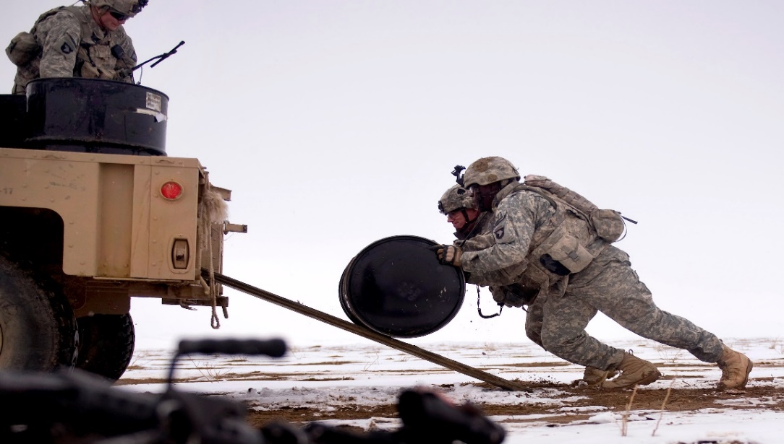

1. Draw a vector diagram, showing all forces when the barrel is halfway up this nearly frictionless plank. (2 marks)
2. If the plank can support a mass of 450 kg, can they safely roll the barrels up the plank? Use calculations to support your answer. (3 marks)

**Question 4 (6 marks)**

A nut on a bolt on a bicycle requires a torque of 6 N m to just loosen it.

1. Label the diagram below and estimate realistic values for the length (L) and force (F) that would just supply enough torque to loosen the nut. (4 marks)



1. ESTIMATE the binding force (B), between the nut and the bolt, which is just sufficient to stop the nut from coming loose. (2 marks)

B = _____________

**Question 5 (3 marks)**

A mass attached to a string is being rotated in a vertical circle by a student as shown in the diagram below. The student increases the speed of the rotation gradually. Using Physics principles, explain at which point (A, B , C or D) the string is most likely to snap as the speed is increased.

c

B

A

D

C

___________________________________________________________________________________________________________________________________________________________________________________________________________________________________________________________________________________________________________________________________________________________________________________________________________________________________________________________________________________________________________________________________________________________________________________________________________________________________________________________________________

**Section Two: Problem solving**  **(31 marks)**

**Question 6 (10 marks)**

A physics student observes a stone of mass 450 g being catapulted from the top of a cliff. The launch position at the top of the cliff is 6.00 m above ground level. The stone lands 20.0 m in front of the launch position. The initial launch speed u is at an angle of 40.0° to the horizontal. You may ignore air resistance for the calculations.

6.00 m

20.0 m

Cliff

40°

Initial launch speed **u**

1. Calculate the initial launch speed **u** of the stone. You must show clear algebraic steps in your solution.

Hint: consider the flight time for both the horizontal and vertical components of motion. (5 marks)

1. Calculate the flight time of the stone. (If you were not able to solve part a), use a numerical value of 12.1 m s-1 for the initial launch speed **u**). (3 marks)
2. Calculate the minimum value of kinetic energy of the stone whilst in flight. (If you were not able to solve part a), use a numerical value of 12.1 m s-1 for the initial launch speed **u**). (2 marks)

**Question 7 (10 marks)**

A 25.0 kg uniform beam PQ is supporting a 60 kg load as shown in the diagram. A cable AB is attached 2.0 m from a frictionless hinge at P, at right angles.

60 KG

A

12 m

B

P

Q

10 m

65o

(a)Find the tension in the cable AB for the position shown. (3 marks)

(b) Find the (reaction) force exerted on the beam by the hinge at P. Be sure to find the magnitude and direction of this force. (5 marks)

(c) The beam is then lowered by lengthening cable AB. State the effect that this change will have by completing the table below (2 marks)

|  |  |
| --- | --- |
|  | Change (increase, decrease unchanged) |
| Magnitude of tension in AB |  |
| Horizontal component of reaction force on beam at P. |  |

**Question 8 (11 marks)**

A satellite is in orbit around the equator of the Earth. It has a mass of 1495 kg and is at an altitude of 1.91 × 104 km above the Earth’s surface.

Satellite

View of Earth from above North Pole

1. Calculate the **period** of this satellite and state your answer in hours.. (4 marks)
2. Explain whether or not a satellite can be geostationary at this altitude. (2 marks)

____________________________________________________________________________________________________________________________________________________________________________________________________________________________________________________________________________________________________________________________________________________________________________

1. Place **labelled** arrow(s) on the diagram to show the direction of the **net acceleration** of the satellite. (1 mark)

*The Earth is a natural satellite that orbits the Sun. (Assume a circular orbit for this question)*

1. Calculate the orbital speed of the Earth as it goes around the Sun. (3 marks)
2. If the Sun was 90% of its current mass, describe how the orbital speed of the Earth would be affected if it remained at the same distance from Sun. (A calculation is not required) (1 mark)